Pre-Algebra
1st 9 weeks test
Name __________________________
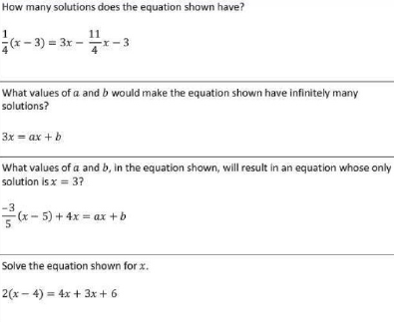
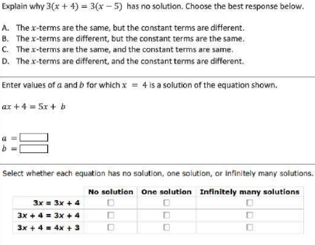

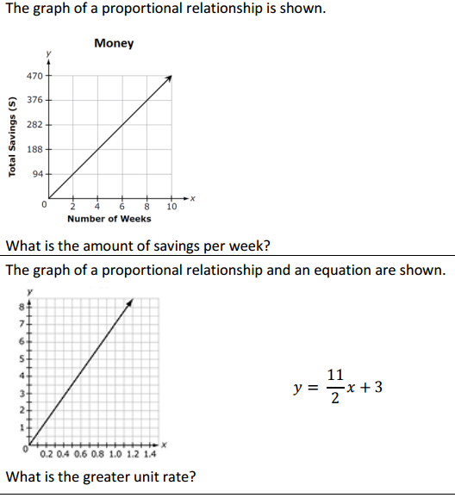

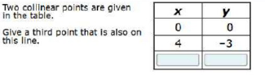

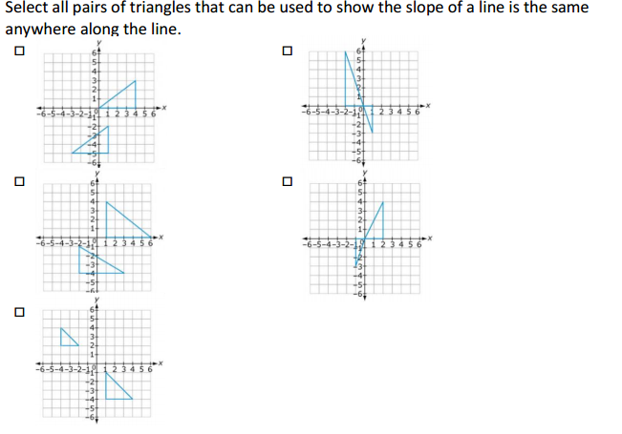

Use the graph to answer the questions below.

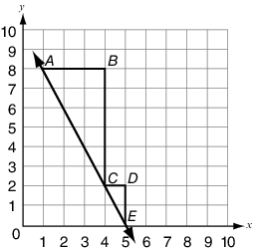

Part A. Explain how the triangle ABC and triangle CDE relate to each other.

Part B. What is the slope of the line given in the graph? Explain how each triangle’s side lengths relate to the slope of the line.

Use words, numbers, and/or pictures to show your work.

