In Exercises 1-4, write an equation of the line with the given slope and   
*y*-intercept.

1. slope:  *y*-intercept: 12 2. slope:  *y*-intercept: 

3. slope:  *y*-intercept:  4. slope:  *y*-intercept: 

In Exercises 5 & 6, write an equation of the line in slope-intercept form.

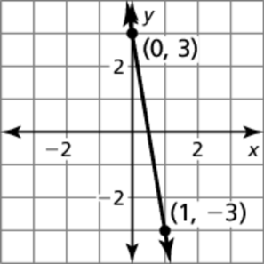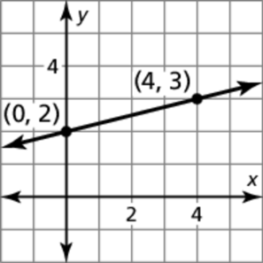 5. 6.

In Exercises 7 & 8, write an equation in point-slope form of the line that passes through the given point and has the given slope.

7.  8. 

In Exercises 9 & 10, write an equation in point-slope form of the line that passes through the given points.

9.  10. 