Name Date

Skill Drill 4

Write the sentence as an inequality.

Answers

1.

2.

3.

4.

5.

6.

See left.

7.

See left.

8.

9.

10.

1. The sum of twice a number *n* and 8 is at most 25.
2. The temperature *t* is at least 

3. The cost of a ticket *t* will be no more than $26.

Write an inequality that represents the graph.

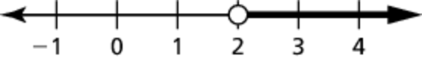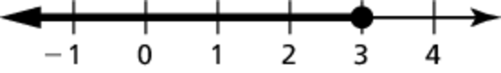 4. 5.

Solve the inequality. Graph the solution.

6.  7. 

TA: K:\BI-HighSchool\Algebra1.01\Ancillaries\production\Alg 1 AB\AB art\Ch 02\HSAlg1_ab_0200_006.eps,3/27/2014 2:38:37 PM replaced: 7/31/2016 1:31:51 PMTA: K:\BI-HighSchool\Algebra1.01\Ancillaries\production\Alg 1 AB\AB art\Ch 02\HSAlg1_ab_0200_007.eps,3/27/2014 2:38:51 PM replaced: 7/31/2016 1:31:51 PM

Solve the inequality.

8.  9. 

10. 