1. | Dequan is writing a system of two equations that has no solutions. The first equation is Write another equation that, when paired with Dequan's first equation, would result in a system of equations with no solutions.

2. | What is the solution to the system of equations shown below?  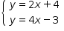  Show or tell how you got your answer.

3. | Jonathan is studying for a math test and encounters the following problem:  Find the solution to this pair of simultaneous linear equations  Jonathan says that all he has to do to solve the problem is determine the slopes of the graphs of the equations.  Part A. Is Jonathan correct? Explain why or why not.  Part B. Find the solution to the system. Show your work.

4. | How many solutions does the system of equations below have?  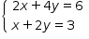

5. | Use the system of equations below to answer the questions.  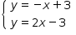  Part A. Graph both the equations on the grid below. Label the solution to the system of equations on the graph.  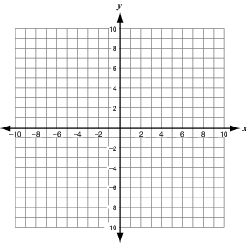  Part B. Check your answer. Explain how you know this is a solution to the system of equations.  Use words, numbers, and/or pictures to show your work.

6. | Amber looks at the following system of equations.  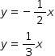  She concludes that because there is no y-intercept value, the lines cannot intersect.  Is Amber's conclusion correct? Explain your answer and support your reasoning with mathematical examples.

7. | The system of linear equations below has an infinite number of solutions.  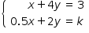  Determine the value of k so that this is true.

