Name Date

Cumulative Review

Chapter

3

Solve the equation and check your answer.

1.  2.  3. 

4.  5.  6. 

7.  8.  9. 

Write and solve an equation to answer the question.

10. It costs $513 for you and your two friends to go skiing for the weekend. How much does it cost for just you to go skiing for the weekend?

11. Your four-month bill for the gym comes to $221. That includes the cost per month of $50 plus the one-time membership fee. How much is the membership fee?

Solve the equation. Check your solution.

12.  13. 

14.  15. 

16. Your cell phone company offers you a choice between two promotional deals. You can either get 500 free text messages with a charge of $0.10 for each text message over 500, or you can get 400 free text messages with a charge of $0.20 for each text message over 400. How many text messages would you have to send for the cost to be the same for either plan?

**Solve the equation. Determine whether the equation has *one solution, no solution,* or *infinitely many solutions*.**

17.  18.  19. 

Solve the equation. Graph the solutions, if possible.

20.  21.  22.  23. 

24. Torque is a measure of how much to tighten a bolt. The torque specification for a   
small-block Chevy V8 is 70 foot-pounds with an error of 0.02 foot-pounds. Write   
and solve an absolute value equation to find the minimum and maximum torque required for the bolts.

Name Date

Cumulative Review (continued)

Chapter

3

Write the sentence as an inequality.

25. A number *n* is at least 20.

26. The number 50 is no more than a number *h* times 2.

Solve the inequality. Graph the solution.

27.  28.  29. 

Write the sentence as an inequality. Then solve the inequality.

30. The difference of 5 and a number is at least 13.

31. A number plus 14 is no more than 2.

**Solve the inequality. Graph the solution, if possible.**

32.  33.  34. 

35.  36.  37. 

Solve the inequality. Graph the solution, if possible.

38.  39.  40. 

Determine whether the relation is a function. Explain.

41.  42. 

43.  44. 

45. 46.

|  |  |  |  |  |
| --- | --- | --- | --- | --- |
| Input | −2 | 0 | 2 | −2 |
| Output | 10 | 7 | 4 | 1 |

|  |  |  |  |  |
| --- | --- | --- | --- | --- |
| *x* | 0 | 1 | 2 | 3 |
| *y* | −2 | 0 | 2 | 4 |

Find the domain and range of each relation, and determine whether or not the graph represents a function.

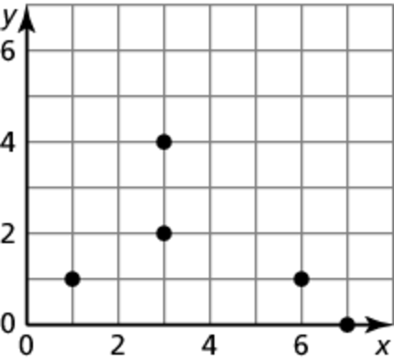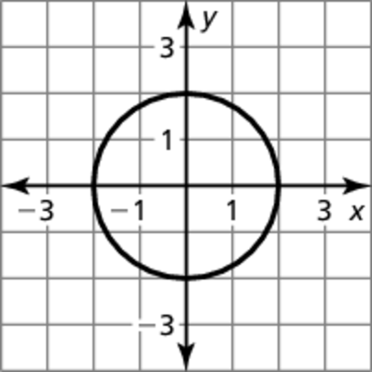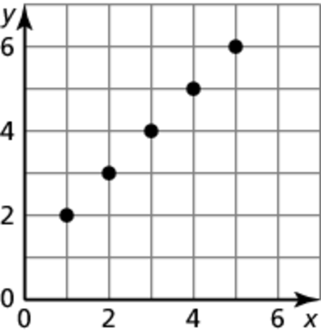 47. 48. 49.

Name Date

Skill Drill 2 (2nd 9 weeks) ----Algebra----

50. The function  represents the amount of money left in your school lunch account *y* (in dollars) after *x* days.

a. Identify the independent and dependent variables.

b. There are 10 days left in the school year. Find the domain and range of the functions.

Determine whether the table represents a *linear* or *nonlinear* function. Explain.

51. 52.

|  |  |  |  |  |
| --- | --- | --- | --- | --- |
| *x* | 0 | 1 | 2 | 3 |
| *y* | 7 | 11 | 15 | 19 |

|  |  |  |  |  |
| --- | --- | --- | --- | --- |
| Input | 2 | 4 | 6 | 8 |
| Output | 1 | 2 | 8 | 16 |

Determine whether the equation represents a *linear* or *nonlinear* function. Explain.

53.  54.  55. 

**Evaluate the function when** 

56.  57.  58. 

**Find the value of *x* so that the function has the given value.**

59.  60.  61. 

Graph the linear function.

62.  63.  64. 

65. The function  represents the average speed of a car that took   
a 108-mile trip in *x* hours.

a. What was the average speed of the car if the trip took 3 hours?

b. How long did the trip take if the average speed was 54 miles per hour?

Find the *x*- and *y*-intercepts of the graph of the linear equation.

66.  67.  68. 

Name Date

Skill Drill 2----Algebra----- (2nd 9 weeks)

Use intercepts to graph the linear equation. Label the points corresponding to the intercepts**.**

69.  70.  71. 

72. You are ordering warm-up clothes for the basketball team. The mesh shirts cost   
$16 each and the cotton shirts cost $8 each. You have a budget of $240 for the shirts. The equation  models the total cost, where *x* is the number of mesh shirts and *y* is the number of cotton shirts.

a. Graph the equation. Interpret the intercepts.

b. Four players decide they want the cotton shirts. How many mesh shirts can   
you order?

The following points lie on a line. Find the slope of the line.

73.  74. 

Find the slope and *y*-intercept. Then graph the linear equation.

75.  76.  77. 

Use the graphs of *f* and *g* to describe the transformation from the graph of *f* to the graph of *g*.

78.   79.  

Write a function *g* in terms of *f* so that the statement is true.

80. The graph of *g* is a vertical stretch by a factor of 3 of the graph of**

81. The graph of *g* is a horizontal translation 4 units right of the graph of**

Graph the function. Compare the graph to the graph of . Describe the domain and range.

82.  83.  84. 

Graph and compare the two functions.

85.  86. ; 