Name Date

Skill Drill 3 (3rd 9 weeks)

In Exercises 1–3, determine whether the function is *even*, *odd*, or *neither*.

1.  2.  3. 

In Exercises 4 and 5, determine whether the function represented by the graph is *even*, *odd*, or *neither*.

4. 5. 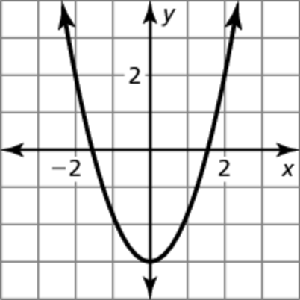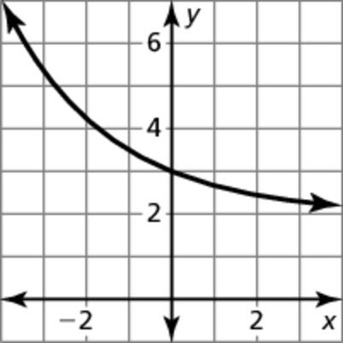

In Exercises 6–8, find the vertex and the axis of symmetry of the graph of   
the function.

6.  7.  8. 

In Exercises 9–11, graph the function. Compare the graph to the graph of 

9.  10.  11. 

In Exercises 12–14, find the vertex and the axis of symmetry of the graph of the function.

12.  13.  14. 

In Exercises 15 and 16, graph the function. Compare the graph to the graph of 

15.  16. 

In Exercises 17 and 18, rewrite the quadratic function in vertex form.

17.  18. 

19. The graph of  is translated 4 units left and 3 units down. Write an equation for the function in vertex form and in standard form. Describe advantages of writing the function in each form.

Name Date

Practice B

8.4

In Exercises 1–3, determine whether the function is *even*, *odd*, or *neither*.

1.  2.  3. 

In Exercises 4 and 5, determine whether the function represented by the graph is *even*, *odd*, or *neither*.

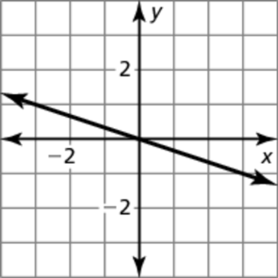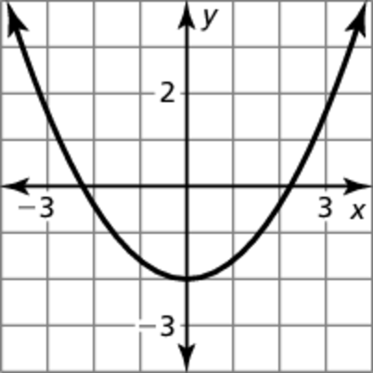 4. 5.

In Exercises 6–8, find the vertex and the axis of symmetry of the graph of the function.

6.  7.  8. 

In Exercises 9–11, graph the function. Compare the graph to the graph of 

9.  10.  11. 

In Exercises 12–14, find the vertex and the axis of symmetry of the graph of   
the function.

12.  13.  14. 

In Exercises 15 and 16, graph the function. Compare the graph to the graph of 

15.  16. 

In Exercises 17 and 18, rewrite the quadratic function in vertex form.

17.  18. 

19. The graph of  is reflected in the *x*-axis and translated 3 units right and   
2 units up. Write an equation for the function in vertex form and in standard form. Describe advantages of writing the function in each form.