Skill Drill 6
Student
Class
Date

1. | Jesse and his brother Mark are each taking separate road trips. Jesse represents his speed on a graph, where y represents distance in miles and x represents time in hours.  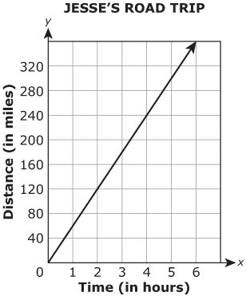  Mark represents his speed with an equation and defines his variables in the same way that Jesse did.  Mark's equation is  Part A. Write Jesse and Mark’s speeds in miles per hour.  Part B. Justify your response for each speed.

2. | Comparing Toy Cars  Taitum and Braeson are taking the same physics class. Taitum uses ticker tape to measure the distance a toy car moves and records the data in the table below. Braeson uses a computer with a camera to measure the distance his car moves. The computer generates the graph shown below.  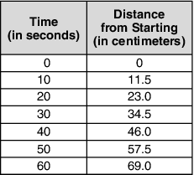  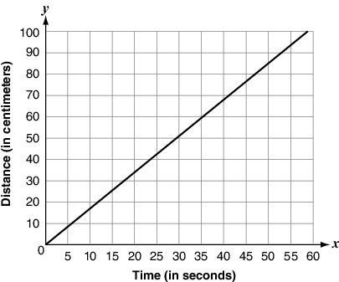  Part A. Compare the speed of the two cars. Is one of the cars faster? If so, by how much? Explain your answer.  Part B. Sketch a graph of Taitum’s data on the same axes as Braeson’s graph. How do the two graphs compare? What is the role of speed in the graphs?  Part C. Write an equation that models the distance each of the cars have gone after t seconds.

 | 3. |  | Part A  Office Supply Store A charges $25 for 75 file folders.  - What is the unit price?  - On a coordinate plane, graph the line that represents the relationship between the number of file folders and the price.  Part B  Another office supply store, Office Supply Store B, also sells file folders. The price of the file folders is shown in the advertisement below.  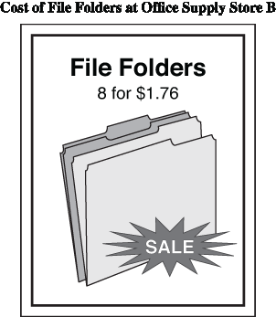  - What is the slope of the line that represents the relationship between the number of file folders and the price at Office Supply Store B?  Part C  - Which store has the lower price for file folders? Explain your answer.

4. | Use the graph to answer the questions below.  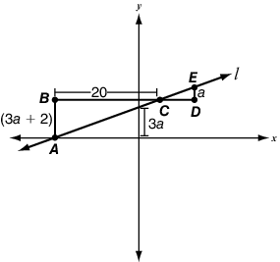  Part A. If triangles ABC and EDC are similar and what is the slope of line l? Show your work.  Part B. What is the equation of line l if it intercepts the y-axis at Show your work.

