Skill Drill 7
Name _________________________________________________

5. | What is the equation, in slope-intercept form, of the line plotted on the graph below?  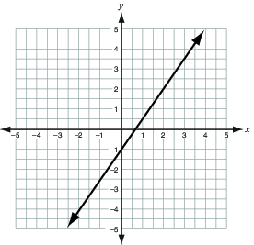

6. | Use the graph to answer the questions below.  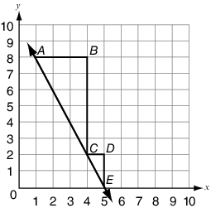  Part A. Explain how the triangle ABC and triangle CDE relate to each other.  Part B. What is the slope of the line given in the graph? Explain how each triangle’s side lengths relate to the slope of the line.  Use words, numbers, and/or pictures to show your work.

7. | Look at the graph below.  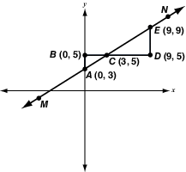  What is the ratio of the vertical side length to the horizontal side length of both the triangles, and how does it compare to the slope of the line

8. | A water tank has a hole from which water is leaking at a constant rate. The table below shows the amount of water in the tank at different intervals of time.  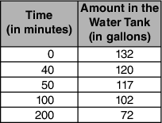  How and at what rate is the amount of water in the tank changing over time?

9. | A train traveling at a constant speed covers 320 miles in 4 hours. What equation can be used to model the distance, d miles, the train travels in time, t hours?

